College of Technology
Computer Technology Department
Second Semester, A. Y. 2024-2025

NAME: SHEEN NICHOLE P. PAGAYON DATE: FEB 11, 2025
INSTRUCTOR: CONCEPCION Q. CORDERO SCORE: /100

Mom gets life imprisonment for selling lewd photos and videos of daughter
TOPIC
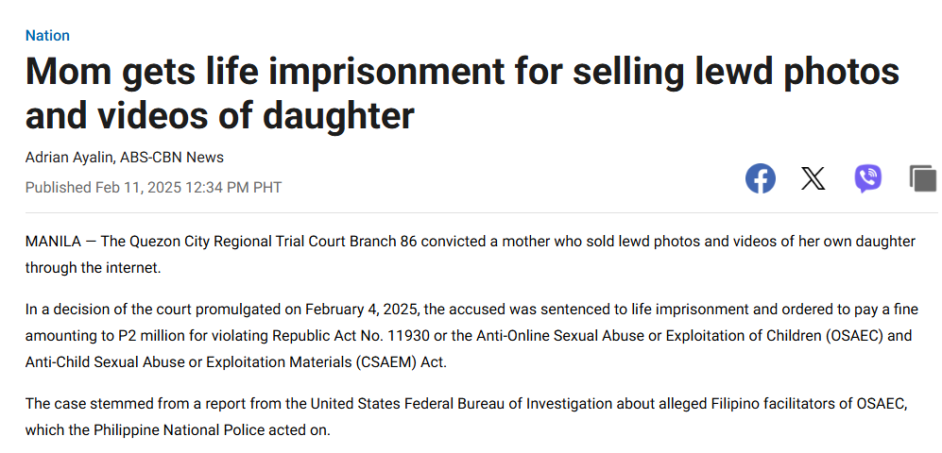
Summary

A mother in Quezon City, Philippines, was sentenced to life imprisonment and fined P2 million for selling lewd photos and videos of her own daughter online. She was convicted under Republic Act No. 11930, the Anti-Online Sexual Abuse or Exploitation of Children (OSAEC) and Anti-Child Sexual Abuse or Exploitation Materials (CSAEM) Act. The case was initiated after a tip from the U.S. Federal Bureau of Investigation (FBI), leading to an entrapment operation where the mother and her husband were arrested. While the mother was found guilty, the father was acquitted due to insufficient evidence of his involvement. Justice Secretary Jesus Crispin Remulla praised the prosecution team and emphasized the need to hold perpetrators accountable.

Insights
The case of a mother exploiting her own daughter by selling lewd photos and videos online is a stark reminder of the pervasive issue of Online Sexual Abuse or Exploitation of Children (OSAEC) in the Philippines. To address this deeply troubling problem, a multi-faceted approach is essential. First, strengthening law enforcement and legal frameworks is critical. This includes stricter implementation of laws like Republic Act No. 11930 and training authorities in digital forensics and victim-sensitive investigations. Second, international collaboration must be enhanced, as many OSAEC cases involve transnational networks. Partnerships with agencies like the FBI and Interpol can help track and dismantle these networks. Public awareness and education are equally important. Nationwide campaigns should educate parents, children, and communities about the dangers of OSAEC and how to report abuse. Empowering children to recognize and speak up against exploitation is also vital, as it reduces their vulnerability.

Support systems for victims must be prioritized to address the long-term trauma they endure. This includes providing psychological, medical, and legal assistance through dedicated child protection centers. Additionally, regulating online platforms and payment systems can curb the facilitation of OSAEC. Tech companies and financial institutions should implement stricter monitoring and reporting mechanisms to flag suspicious activities. Addressing the root causes of exploitation, such as poverty and lack of education, is another crucial step. Livelihood programs and community development initiatives can reduce the economic desperation that often drives such crimes. Finally, community involvement is key. Encouraging locals to report suspected cases through hotlines and anonymous systems can create a safer environment for children. By taking these comprehensive steps, society can work toward preventing OSAEC, protecting vulnerable children, and ensuring justice for victims.
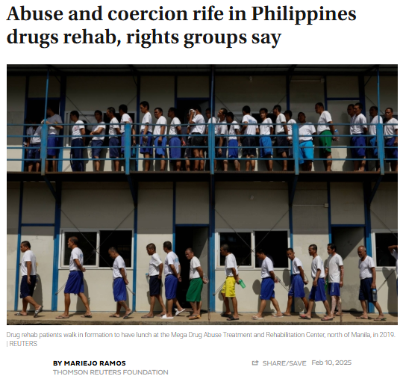
Abuse and coercion rife in Philippines drugs rehab
TOPIC

Summary

During the Philippines’ "war on drugs" launched in 2016, thousands of people, particularly from poor communities, were subjected to extreme measures, including extrajudicial killings, forced rehabilitation, and harsh drug policies. Some, like Liza Igcasinza, were forced into rehabilitation programs after police raids and vigilante killings of suspected drug users and dealers.
Although the government claimed to offer rehabilitation as an alternative to incarceration or death, many facilities operated under coercion, military-style discipline, and inhumane conditions. International organizations, including the International Criminal Court (ICC) and Amnesty International, have investigated and criticized these methods as human rights violations.
While the current administration under President Ferdinand Marcos Jr. has pledged a "bloodless" campaign, rights groups argue that the punitive approach persists. Rehabilitation remains compulsory rather than voluntary, and there is little government support for reintegration into society. Experts emphasize that poverty is a major driver of drug use, yet government policies continue to focus on punishment rather than addressing underlying social and economic issues.
Insights
The Philippine government must shift its approach to drug use from a punitive model to a health-based strategy. Drug use should be recognized as a public health issue rather than a criminal offense, ensuring that rehabilitation is voluntary and evidence-based rather than forced. Implementing community-based treatment programs that provide mental health support, job training, and social services will help drug users reintegrate into society rather than be trapped in a cycle of stigma and punishment. Moreover, rehabilitation centers should follow international standards set by the WHO and UNODC, ensuring humane and science-backed treatment methods.
Beyond rehabilitation, it is essential to address poverty and unemployment, which are key drivers of drug use. Expanding access to livelihood programs, education, and social services will prevent people from turning to drugs in the first place. At the community level, awareness campaigns and stigma reduction efforts can help recovering drug users regain acceptance and rebuild their lives. Additionally, there must be stronger accountability measures to investigate and address past human rights violations committed during the war on drugs. The government should cooperate with international investigations, provide justice and reparations to victims, and establish independent oversight to prevent future abuses by law enforcement.
Finally, the Philippines should look to successful global models, such as Portugal and Switzerland, where drug addiction is treated as a health concern rather than a criminal offense. Harm reduction strategies, including supervised drug use programs, rehabilitation incentives, and mental health interventions, should be considered. Instead of relying on law enforcement as the primary response, the government should partner with healthcare professionals, NGOs, and social workers to create a more compassionate and effective approach. By implementing these changes, the Philippines can move away from fear-based policies and toward a more humane, just, and effective drug reform strategy.

Catholic Church in the Philippines Accused of Impunity Over Priest Abuse
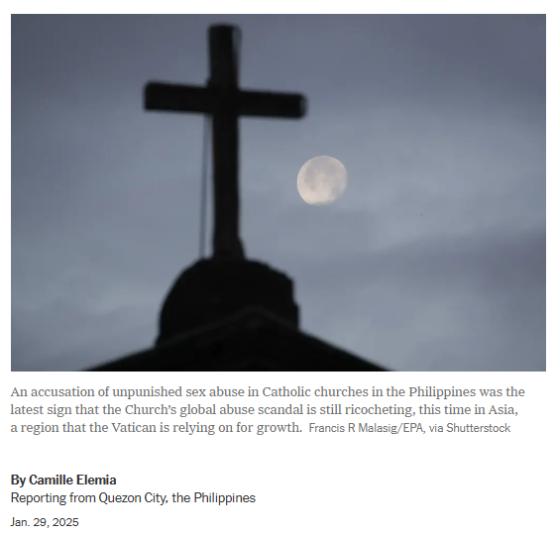
TOPIC

Summary
A watchdog group, Bishop Accountability, has accused the Catholic Church in the Philippines of fostering a culture of impunity regarding child sexual abuse by clergy members. The group identified 82 priests and brothers accused of abuse, many of whom remain in active ministry. Despite serious allegations, no priest has been convicted in the country, highlighting a failure of accountability. While Pope Francis has mandated reforms, including requiring every diocese to establish systems for reporting abuse, critics argue that the Church in the Philippines has not effectively implemented these measures. The Catholic Bishops Conference of the Philippines (CBCP) claims it lacks direct authority to investigate or discipline clergy, leaving enforcement to Rome. Meanwhile, some priests accused of abuse have been reassigned rather than held accountable. The issue remains largely unaddressed due to a lack of transparency, legal enforcement, and victim protection.
Insights
To effectively combat this issue, urgent reforms are needed at both the legal and institutional levels. First, all allegations of abuse should be handled by independent law enforcement, not just internal Church investigations. There must be strict enforcement of legal consequences for offenders, ensuring they face criminal prosecution rather than reassignment. Second, the Church should be required to publicly disclose all known cases of abuse and fully cooperate with authorities. Transparency is key to ending impunity. Third, victim support systems must be strengthened, including providing psychological care, legal assistance, and protection for those who come forward. Fourth, public awareness campaigns should be launched to encourage victims and witnesses to report abuse without fear of stigma or retaliation. Lastly, Church reforms should include independent oversight bodies that monitor how abuse cases are handled, ensuring that the Church does not police itself. Without these steps, impunity will persist, and more individuals could suffer from abuse. Ensuring justice and accountability is critical to protecting vulnerable individuals and restoring trust in institutions meant to uphold moral values.

Philippines suspends South China Sea survey after China’s ‘harassment’
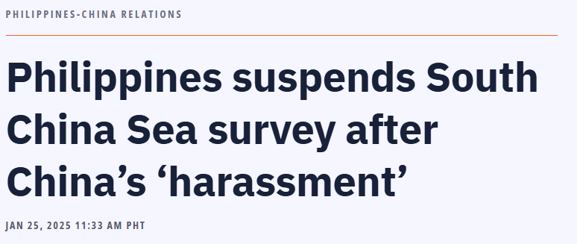
TOPIC
Summary
The Philippines has suspended a scientific survey in the South China Sea following harassment and aggressive actions by China’s coast guard and navy. On January 24, two Philippine Bureau of Fisheries vessels, en route to collect sand samples from Sandy Cay near Thitu Island, were met with aggressive maneuvers from three Chinese Coast Guard vessels. Additionally, China deployed four small boats to harass two rigid hull inflatable boats used by the fisheries bureau to transport personnel. This incident is part of an ongoing series of confrontations between the Philippines and China over disputed waters in the South China Sea, a region of strategic importance where $3 trillion worth of trade passes annually.
Insights
To address this escalating tension, the Philippine government must take a firm yet strategic approach. First, diplomatic measures should be intensified by raising the issue in international forums, such as the United Nations and ASEAN, to rally support and increase pressure on China to respect international maritime laws. Second, stronger maritime patrols and defense cooperation with allied nations, such as the United States, Japan, and Australia, should be pursued to deter further aggression. Third, legal avenues must be reinforced, leveraging the 2016 ruling by the Permanent Court of Arbitration, which invalidated China’s expansive claims over the South China Sea. Fourth, the Philippines should continue enhancing its naval and coast guard capabilities to ensure the protection of its territorial waters. Lastly, public awareness and national unity must be strengthened to resist external pressures and assert the country’s sovereign rights. Without these measures, China’s continued aggression may further challenge the Philippines' territorial integrity and maritime security.
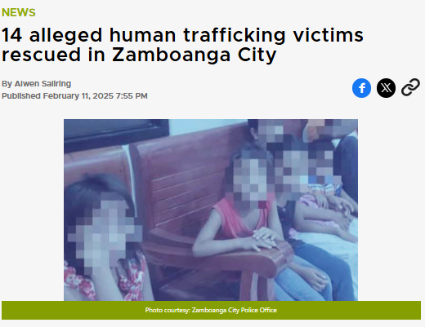
14 alleged human trafficking victims rescued in Zamboanga City
TOPIC
Summary
Authorities in Zamboanga City successfully rescued 14 alleged victims of human trafficking, most of whom were children aged between two and twelve years old. Two suspects were arrested and are now facing legal charges. The victims have been turned over to the Department of Social Welfare and Development (DSWD) for care and support. The Zamboanga City Police Office (ZCPO) emphasized its commitment to protecting vulnerable populations, particularly children, and acknowledged that Zamboanga’s strategic location near maritime routes makes it a target for human trafficking. The police vowed to continue collaborating with other agencies to combat the crime and called on the public to stay vigilant in protecting children from exploitation.
Insights
To effectively combat human trafficking, a multi-pronged approach is necessary. First, law enforcement agencies should increase surveillance and intelligence operations in trafficking hotspots, particularly in maritime areas where illegal transport often occurs. Second, stricter penalties and faster prosecution of traffickers must be ensured to deter perpetrators and send a strong message that such crimes will not be tolerated. Third, community awareness campaigns should be intensified, educating citizens on recognizing trafficking signs and reporting suspicious activities. Fourth, greater support for victims is crucial, including psychological care, rehabilitation programs, and reintegration efforts to help them recover from trauma. Lastly, cross-agency and international cooperation should be strengthened to track and dismantle trafficking networks that extend beyond national borders. Without sustained efforts, human trafficking will continue to threaten the safety and well-being of vulnerable individuals, particularly children.

References:

Ayalin, A. (2025, February 11). Mom gets life imprisonment for selling lewd photos and videos of daughter | ABS-CBN News. ABS-CBN. https://www.abs-cbn.com/news/nation/2025/2/11/mom-gets-life-imprisonment-for-selling-lewd-photos-and-videos-of-daughter-1234
‌
Ramos, M. (2025, February 10). Abuse and coercion rife in Philippines drugs rehab, rights groups say. The Japan Times. https://www.japantimes.co.jp/news/2025/02/10/asia-pacific/crime-legal/abuse-philippines-drugs-rehab/

Elemia, C. (2025, January 29). Catholic Church in the Philippines Accused of Impunity Over Priest Abuse. Nytimes.com; The New York Times. https://www.nytimes.com/2025/01/29/world/asia/philippines-catholic-priests-abuse.html
‌
Gavilan, J. (2025, January 25). Philippines suspends South China Sea survey after China’s “harassment.” RAPPLER. https://www.rappler.com/philippines/south-china-sea-survey-suspension-after-harassment-coast-guard/
‌
14 alleged human trafficking victims rescued in Zamboanga City. (2025). Gmanetwork.com. https://www.gmanetwork.com/regionaltv/news/106558/14-alleged-human-trafficking-victims-rescued-in-zamboanga-city/story/
‌

Prepared by:

SHEEN NICHOLE P. PAGAYON
Student’s Signature Over Printed Name

Graded by:
CONCEPCION Q. CORDERO, MAELT, LPT
Course Instructor

